Unit 2:
HAZARDOUS MATERIALS IDENTIFICATION SYSTEMS

OBJECTIVES

In this unit, you will learn about:

- The National Fire Protection Association’s 704 System

- Transportation of Hazardous Materials under the Department of Transportation’s System

- The 2004 Emergency Response Guidebook

- Hazards associated with toxic industrial chemicals (TICs)

- Military designation of prominent chemical warfare agents (CWAs)

INTRODUCTION

Hazardous materials are frequently stored and transported in large quantities. An accidental release of these materials presents a potential danger to the public and the environment. Such an incident can be managed more expeditiously when the hazardous materials are specifically identified and characterized. Unfortunately, the contents of storage tanks and trucks may not be specifically or properly identified. Records or shipping papers may be inaccessible. Even with such information, an experienced person is needed to define the hazards and the gravity of the situation.

The immediate need for information concerning a hazardous material during an incident is vital. Therefore, two hazardous materials identification systems have been developed.

Both systems help first responders to deal with the hazardous materials present quickly and safely. Both were devised for personnel with no real training in chemistry.

- The first is the National Fire Protection Association (NFPA) 704 System, which is used on storage tanks and smaller containers (fixed facilities).

- The second system is used exclusively on containers and tanks transported in interstate commerce. The U.S. Department of Transportation (DOT) is responsible for this system. Information concerning chemical properties and hazards in transport is displayed by way of placards and labels. The DOT regulation covering this system is the Code of Federal Regulations 49 (CFR 49).
THE NATIONAL FIRE PROTECTION ASSOCIATION’S (NFPA’s) 704 SYSTEM

The National Fire Protection Association (NFPA) has devised a voluntary marking system to alert firefighters to the characteristics of hazardous materials stored in stationary tanks and facilities. This system, known as NFPA 704, can also assist citizens visiting a site in identifying the hazard presented by the stored substance. Use of the system is voluntary, unless specified by local codes.

NFPA 704 is a standardized system, which uses numbers and colors on a sign to indicate the basic hazards of a specific material being stored in large containers. Health, flammability, reactivity, and special hazards are identified and rated on a scale of 4 to 0 depending on the degree of hazard presented by the material (Figure 2-1).

The rating of individual chemicals can be found in the NFPA “Guide to Hazardous Materials.” Other references such as the National Safety Council’s “Fundamentals of Industrial Hygiene” contain the NFPA ratings for specific materials. Such information can be used not only during an emergency, but also when long-term remedial activities require extensive evaluation.

The NFPA 704 system for hazardous materials was devised to provide at-a-glance information to response personnel on how a substance could be expected to react in the event of an emergency.

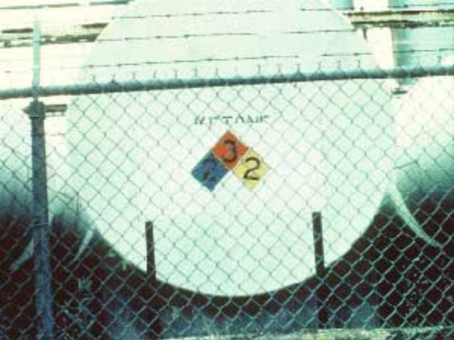 The NFPA 704 label is diamond-shaped, and is
divided into four parts, or quadrants.

The left quadrant is blue, and contains a
numerical rating of the substance’s health
hazard. Ratings are made on a scale of 4 to 0,
with a rating of 4 indicating a severe hazard that
a very short exposure could cause serious injury
or death. A zero, or no code at all in this quarter,
means that no unusual hazard would result from
the exposure.

Figure 2-1, Example of NFPA 704 System

The top quadrant of the NFPA symbol contains the substance’s fire hazard rating. As you might expect, this quadrant is red. Again, number codes in this quadrant range from 4 to 0, with 3 representing a serious fire hazard. See Figure 2-1.

The NFPA label’s right quadrant, colored yellow, indicates the substance’s likelihood to explode or react. As with the health and fire hazard quadrants, ratings from 4 to 0 are used to indicate the degree of hazard. If a 2 appears in this section, the chemical is moderately unstable, and even under NORMAL conditions may explode or react violently. A zero in this quadrant indicates that the material is considered to be stable even in the event of a fire.
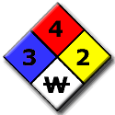
Figure 2-2, NFPA 704 System

The bottom quadrant is white, and contains information about any special hazards that may apply. There are three possible codes for the bottom quarter of the NFPA symbol:

- OXY means this material is an oxidizer. It can easily release oxygen to create or worsen a fire or explosion hazard.

- The symbol W indicates a material that reacts with water to release a gas that is either flammable or hazardous to health. See Figure 2-2.

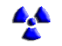
- If the material is radioactive, the usual tri-blade “propeller” symbol for radioactivity will appear.

It is important to remember that the system is chemical-specific. No chemical identification system can accurately assess the synergistic effects of one chemical combining with another, or the possible effects of combining unknown amounts of several chemicals.

The Department of Transportation (DOT), in cooperation with the United Nations, has devised an international classification system, which tags hazardous materials in transit with color-coded, symbolic warning placards.

DEPARTMENT OF TRANSPORTATION’S (DOT’s) IDENTIFICATION SYSTEM

Hazardous materials are transported daily in the United States by air, water, road, rail, and pipeline. Of the 1.5 billion tons of hazardous materials transported in this country each year, more than half move by tankers along the Nation’s highways.

Highway transport of hazardous materials is so common that it is doubtful that any area of the country could be considered free of the threat of an accident. Sound State and local policies to regulate this transportation safely, and to ensure that firefighters and others who would respond to an incident are well prepared, are essential.

The DOT’s Hazardous Materials Transportation Administration regulates more than 1,700 hazardous materials. The regulation requires labels on small containers and placards on tanks and trailers (Figure 2-3). The placards and labels indicate the most serious hazard presented by the cargo being transported.

DOT PLACARDS AND LABELS
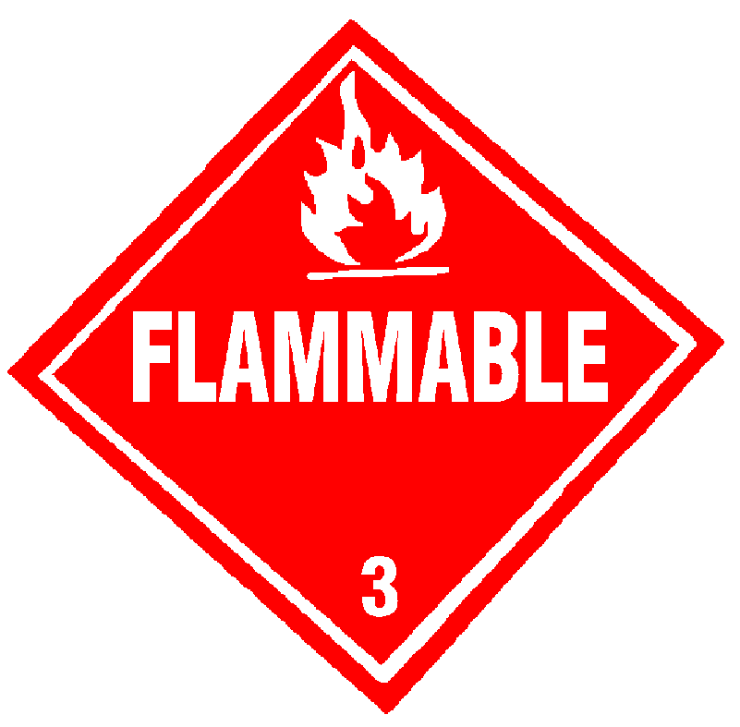
The Department of Transportation, working with the United Nations, has developed an international classification system for hazardous materials. A substance is classified as hazardous if it “poses an unreasonable risk to public health and safety” when transported. Federal legislation requires that cargo tanks and railroad tank cars, which are carrying regulated hazardous contents between States, bear a four-digit code number (1219). See Figure 2-5 on page 2-9.

Figure 2-3, DOT Flammable Liquid Placard

This code, called a North American (NA) or United Nations (UN) ID number, is located on placards or panels placed on all four sides of the cargo tank or rail car. If you are concerned about what sort of hazardous materials are passing through your community, you can use these UN ID numbers to categorize the transport vehicles by load. Interpretations of these codes are found in DOT’s Emergency Response Guidebook, which may be obtained through DOT. You can also contact your LEPC to determine the stationary locations of chemicals in your area, and ask the companies involved regarding the origination and destination of chemicals stored there.

DOT Hazard Classification System

The hazard class of dangerous goods is indicated either by its hazard class (or division) number or name. For a placard corresponding to the primary hazard class of a material, the hazard class or division number must be displayed in the lower corner of the placard. However, no hazard class or division number may be displayed on a placard representing the subsidiary hazard of a material. For other than Class 7 or the OXYGEN placard, text indicating a hazard (for example, “CORROSIVE”) is not required. Text is shown only in the United States. The hazard class or division number must appear on the shipping document after each shipping name. The DOT hazard classes and divisions are as follows:

Hazard Class 1

Class 1 | Explosives | 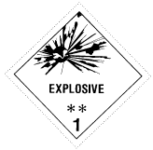
Division 1.1 | Explosives with a mass explosion hazard
Division 1.2 | Explosives with a projection hazard
Division 1.3 | Explosives with predominantly a fire hazard
Division 1.4 | Explosives with no significant blast hazard
Division 1.5 | Very insensitive explosives; blasting agents
Division 1.6 | Extremely insensitive detonating articles

For the purposes of this discussion, an explosive means any substance or article, including a device, which is designed to function by explosion (i.e., an extremely rapid release of gas and heat) or which, by chemical reaction within itself, is able to function in a similar manner even if not designed to function by explosion, unless the substance or article is otherwise classed under the provisions of this subchapter. The term includes a pyrotechnic substance or article, unless the substance or article is otherwise classed under the provisions of this subchapter.

Explosives in Class 1 are divided into six divisions as follows:

- Division 1.1 consists of explosives that have a mass explosion hazard. A mass explosion is one that affects almost the entire load instantaneously.

- Division 1.2 consists of explosives that have a projection hazard but not a mass explosion hazard.

- Division 1.3 consists of explosives that have a fire hazard and either a minor blast hazard or a minor projection hazard or both, but not a mass explosion hazard.

- Division 1.4 consists of explosives that present a minor explosion hazard. The explosive effects are largely confined to the package and no projection of fragments of appreciable size or range is to be expected. An external fire must not cause virtually instantaneous explosion of almost the entire contents of the package.

- Division 1.5 consists of very insensitive explosives. This division is comprised of substances that have a mass explosion hazard but are so insensitive that there is very little probability of initiation or of transition from burning to detonation under normal conditions of transport.

- Division 1.6 consists of extremely insensitive articles, which do not have a mass explosive hazard. This division is comprised of articles which contain only extremely insensitive detonating substances and which demonstrate a negligible probability of accidental initiation or propagation.

Hazard Class 2

Class 2 | Gases | 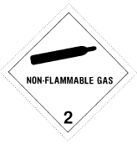
Division 2.1 | Flammable gases
Division 2.2 | Non-flammable, non-toxic* compressed gases
Division 2.3 | Gases toxic* by inhalation
Division 2.4 | Corrosive gases (Canada)

- Division 2.1 Flammable compressed gas. Compressed gases are labeled according to their flammability. A compressed gas is defined as a material or mixture that has in its container either an absolute pressure exceeding 40 PSI at 70 degrees F, an absolute pressure exceeding 104 PSI at 130 degrees F, or both; or any liquid flammable material that has a Reid vapor pressure exceeding 40 PSI absolute at 100 degrees F.

Division 2.2 Non-flammable compressed gas.

Division 2.3 Poisonous gas.

Division 2.4 Corrosive gas (Canadian).

Hazard Class 3

Class 3 | Flammable liquids, Combustible liquids [U.S.] | 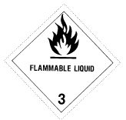
No Divisions

Flammable Liquids. Flammable liquid is one that evolves flammable vapors in air at a temperature of 140 degrees F or below as determined by a specific method.

Combustible liquids. A combustible liquid is one that evolves combustible vapors in air at a temperature between 140 degrees F and 200 degrees F as determined by a specific method.

Hazard Class 4

Class 4 | Flammable solids, Spontaneously combustible materials, and Dangerous when wet materials | 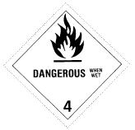
Division 4.1 | Flammable solids
Division 4.2 | Spontaneously combustible materials
Division 4.3 | Dangerous when wet materials

Division 4.1 Flammable solids. Flammable solids include materials other than explosives that are likely to cause fire by self-ignition through friction, absorption of moisture, spontaneous chemical changes, or as a result of heating.

Division 4.2 Spontaneously combustible materials.

Division 4.3 Dangerous when wet materials.

Hazard Class 5

Class 5 | Oxidizers and Organic peroxides | 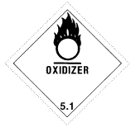
Division 5.1 | Oxidizers
Division 5.2 | Organic peroxides

Division 5.1 Oxidizers. Oxidizing materials are substances that yield oxygen readily to stimulate the combustion of organic materials.

Division 5.2 Organic peroxide.

Hazard Class 6

Class 6 | Toxic* materials and Infectious substances | 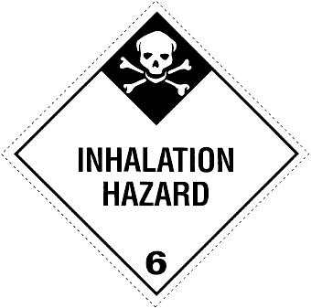
Division 6.1 | Toxic* materials
Division 6.2 | Infectious substances

Division 6.1 Toxic materials. These include chemical warfare agents.

Division 6.2 Infectious substance (etiologic or disease-causing) agents.
* The words “poison” or “poisonous” are synonymous with the word “toxic.”

Hazard Class 7

Class 7 | Radioactive materials | 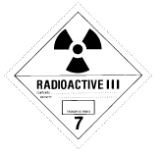
No Divisions

Radioactive. Radioactive materials are particles or radioactive waves which are capable of killing or damaging cells. Radioactive materials have three labels: White I Label, Yellow II and III Labels.

Hazard Class 8

Class 8 | Corrosive materials | 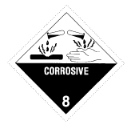
No Divisions

Corrosives. Corrosive materials are liquids or solids that are capable of causing visible destruction or irreversible alteration in metals or human skin tissue at the site of contact.

Hazard Class 9

Class 9 | Miscellaneous dangerous goods | 
Division 9.1 | Miscellaneous dangerous goods (Canada)
Division 9.2 | Environmentally hazardous substances (Canada)
Division 9.3 | Dangerous wastes (Canada)

Miscellaneous hazardous materials.

Environmentally hazardous substances, liquids, and solids.

Dangerous wastes (Canada).

SHIPPING DOCUMENTS (PAPERS)

The shipping document provides vital information when responding to a hazardous materials/dangerous goods incident. The shipping document contains information needed to identify the materials involved. Use this information to initiate protective actions for your own safety and the safety of the public. The shipping document contains the proper shipping name, the hazard class or division of the material(s), ID number and, where appropriate, the Packing Group number. In addition, there must be information available that describes the hazards of the material that can be used in the mitigation of an incident. The information must be entered on or be with the shipping document. See Figure 2-4 on the next page.

This requirement may be satisfied by attaching a guide from the ERG2004 to the shipping document, or by having the entire guidebook available for ready reference. Shipping documents are required for most dangerous goods in transportation. Shipping documents are kept in the cab of the motor vehicle, in the possession of the train crewmember, in a holder on the bridge of a vessel, or in the possession of the aircraft’s captain.

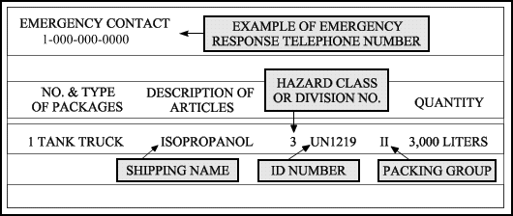
Figure 2-4, Sample Shipping Paper Entry

EXAMPLE OF PLACARD AND PANEL WITH ID NUMBER

The four-digit ID Number may be shown on the diamond-shaped placard or on an adjacent orange panel displayed next to the placard on the ends and sides of a cargo tank, vehicle, or rail car. See Figure 2-5 below. For more labeling and placarding information, consult 49 CFR 172.400 and 500.
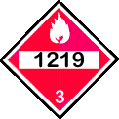  Figure 2-5, Placard | A Numbered  Placard | or | A Placard  and an  Orange Panel | 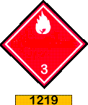  Placard and Panel

For the purposes of this unit, the terms “shipping document/shipping paper” are synonymous; and the terms “hazardous materials/dangerous goods” are used interchangeably. Shipping papers must accompany every HazMat shipment and be available for inspection. Drivers must keep shipping papers on the seat next to them within arm’s reach or in the driver’s side door. Shipping papers describe the HazMat being transported and contain valuable information for responders in the event of an incident or accident resulting in the spill or release of these materials.

ERG2004 USER’S GUIDE
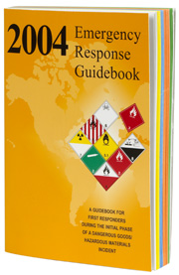
The 2004 Emergency Response Guidebook (ERG2004) was developed jointly by Transport Canada (TC), the U.S. Department of Transportation (DOT), the Secretariat of Transport and
Communications of Mexico (SCT), and with the collaboration of CIQUIME (Centro de Información Química para Emergencias) of Argentina, for use by firefighters, police, and other emergency services personnel who may be the first to arrive at the scene of a transportation incident involving dangerous goods and HazMat (see Figure 2-6). It is primarily a guide to aid “first responders” in quickly identifying the specific or generic hazards of the material(s) involved in the incident, and protecting themselves and the general public during the initial response phase of the incident.

Figure 2-6, 2004 ERG

Initial Response Phase

The “initial response phase” is that period following arrival at the scene of an incident during which the presence and/or identification of dangerous goods is confirmed, protective actions and area securement are initiated, and assistance of qualified personnel is requested. It is not intended to provide information on the physical or chemical properties of dangerous goods.

The ERG2004 is designed to assist responders in making initial decisions upon arriving at the scene of a dangerous goods incident. It should not be considered as a substitute for emergency response training, knowledge, or sound judgment. ERG2004 does not address all possible circumstances that may be associated with a dangerous goods incident. It is primarily designed for use at a dangerous goods incident occurring on a highway or railroad. Be mindful that there may be limited value in its application at fixed facility locations.

ERG2004 incorporates dangerous goods lists from the most recent United Nations
recommendations as well as from other international and national regulations. Explosives are
not listed individually by either proper shipping name or ID Number. They do, however,
appear under the general heading “Explosives” on the first page of the ID Number index
(yellow-bordered pages) and alphabetically in the Name of Material index (blue-bordered pages). Also, the letter “P” following the guide number in the yellow-bordered and blue-bordered
pages identifies those materials which present a polymerization hazard under certain conditions, for example: Acrolein, stabilized 131P.

First Responders

First responders at the scene of a dangerous goods or HazMat incident should seek additional specific information about any material in question as soon as possible. The information received by contacting the appropriate emergency response agency, the emergency response number on
the shipping document, or by consulting the information on or accompanying the shipping
document, may be more specific and accurate than this guidebook in providing guidance for the
materials involved.

BECOME FAMILIAR WITH THIS GUIDEBOOK BEFORE USING IT DURING AN
EMERGENCY! In the U.S., according to the requirements of the U.S. Department of Labor’s
Occupational Safety and Health Administration (OSHA, 29 CFR 1910.120), and regulations
issued by the U.S. Environmental Protection Agency (EPA, 40 CFR Part 311), first responders
must be trained regarding the use of this ERG. The ERG can be obtained from the DOT for “first responders” or from private vendors for less than $4.00 a copy.

Most Transportation Accidents

Most transportation accidents involve flammable or combustible liquids (hazard class 3). These materials are also the most transported by volume. They are substances that have low flash points, and include the frequently transported fuel, gasoline. The flash point of a liquid is the point at which sufficient vapor is produced to cause it to flash in the presence of an ignition source. The lower the flash point, the more volatile the substance.

The second most frequent type of incident involves corrosives (hazard class 8), defined by DOT as “any liquid or solid that can destroy human skin tissue, or any liquid that has a severe corrosion rate on steel.” This class includes acids (such as sulfuric acid, used in chemical processing; and nitric acid, commonly used in the manufacture of fertilizers, explosives, and synthetic fibers) and bases (such as sodium hydroxide, used to purify petroleum products and in the manufacture of soap, pulp, and paper).

APPROPRIATELY LABELED AND PLACARDED

Hazardous materials containers in transportation are required to be appropriately labeled and the vehicle placarded when the hazardous materials’ gross aggregate weight exceeds 1001 pounds; or they are classified as Table 1 materials. (Table 1 materials are required to have placards regardless of the amount being transported.) Labeling and placarding information can be found in 49 CFR 172.400, and 172.500 respectively.

How to Lessen the Impact of Accidents

How can your community lessen the impact of a serious accident involving a hazardous material? One good way is to be sure that existing regulations are enforced. This may require a substantial commitment in human resources. Another community responsibility is to ensure that the area has a good emergency plan for handling this type of incident, and that confusion over jurisdiction (“who’s in charge?” and “who’s in charge of what?”) will not hinder an effective response. Hazardous materials routing through a community is designed to lessen the impact of a HMI.

TOXIC INDUSTRIAL CHEMICALS (TICs)

The term “toxic industrial chemical” refers to a variety of chemicals used by industry in various processes, created by industry for various purposes, or released to the soil, to water, or to the air by industry as byproducts of either. Any chemical can be toxic or harmful in some dose, and the most dangerous of TICs are those that have harmful effects in relatively low doses when in air or in contact with skin or eyes.
The potential exists for first responders and surrounding populations located downwind or near such an industry to be exposed to levels that may impact their health. (See Figure 2-7 below.) Toxic industrial chemicals (TIC) may pose a high risk when they are stored in large quantities in one location. An act of sabotage or an accident can result in a large release of liquids, which could volatize and be breathed in by those nearby, or travel some distance downwind. An example would be a release of chlorine gas from a large tank into the surrounding air. Such a release could cause injuries and deaths into the thousands.
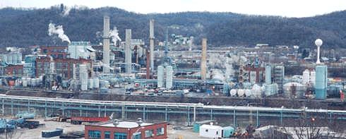
Figure 2-7, Chemical Refinery

TICs may pose a terrorist threat as a weapon of mass destruction (WMD). Rail cars, tanker trucks, and fixed facilities are considered by some authorities as “soft targets” and could be high on the terrorist’s hit list. (See Figure 2-8 below.) Described on the next page are a few TICs, commonly called chemical warfare agents (CWA). The ability to detect an immediate hazard and take corrective action can save your life. Increased security measures are being implemented around these sites which could be “targets of opportunity.”
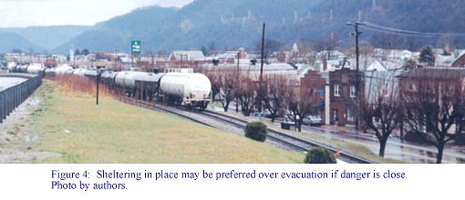
Figure 2-8, Parked Rail Cars

Excellent data on rail traffic can be obtained from the Federal Railroad Administration (FRA) and the individual railway lines serving your area. Many individual rail lines can provide detailed information on the hazardous materials shipments in your area.
In addition, State regulatory agencies can tell you which hazardous materials travel most frequently by rail in your State.

CHEMICAL WARFARE AGENTS (CWA) AND TIC

Phosgene and Chlorine

Phosgene (CG) and chlorine (CL) are lung-damaging agents. They are the first chemical warfare agents (CWA) used and are also classified as TICs. They are shipped via rail cars and tanker trucks daily throughout the United States. Phosgene and chlorine cause irritation of the bronchi, trachea, larynx, pharynx, and nose, and may contribute to the sensation of choking. Initial symptoms include eye irritation, burning, pulmonary irritation, running nose (rhinorrhea), cough, dyspnea, chest tightness, reddening of the skin (erythema), and lung damage (pulmonary edema).

Decontaminate (remove clothing and wash your entire body with soap and water) and do not exert yourself if you have been exposed to one of these agents.

Cyanides

Cyanides are classified as blood agents. They are called blood agents because they produce their effects by interfering with oxygen utilization at the cellular level. The Chemical Warfare Agents (CWA) that could be possible terrorist’s weapons are: Hydrogen Cyanide and Cyanogen Chloride.

Their Military Designations are: AC (hydrocyanic acid) and CK (cyanogen chloride). Both of these substances are liquids, but they vaporize (evaporate) at about 73°F and 23°C, so they will be in a gaseous form under standard temperature and pressure (STP). AC has an odor of bitter almonds; CK is pungent. AC vapor is lighter than air, whereas CK gas is heavier than air.
Inhalation is the usual route of entry of these chemicals. Initial symptoms are rapid shallow breathing, followed by vertigo and nausea. Progressive symptoms include a decrease in respiratory rate, convulsions, cessation of breathing, and cardiac arrhythmia over 2 to 4 minutes depending on the dose and exposure time. The symptoms of cyanide poisoning include:

- Dryness and burning of the throat | - Convulsion and coma
- Dyspnea, or shortness of breath | - Cardiovascular collapse
- Hyperpnea, rapid shallow breathing | - Death
- Apnea, lack of breathing

Decontamination is usually not necessary because cyanide evaporates rapidly, but skin under cyanide-contaminated clothing should be washed with soap and water.

For water transportation facts, the Army Corps of Engineers and the U.S. Coast Guard are most likely to be of assistance, while the Federal Aviation Administration is the best source for data on air traffic. The safety of our Nation does not rest entirely with the Department of Homeland Security, but with each citizen’s vigilance and timely reporting to their local law enforcement agency any suspicious activities of any person in and around one of the possible “targets of opportunity” mentioned above. See also the National Response Center’s guidance on page B-7.

COMMODITY FLOW SURVEY (CFS)
The Commodity Flow Survey (CFS) contains data on shipments by domestic establishments in manufacturing, wholesale, mining, and selected other industries. The U.S. Census Bureau, in partnership with the Bureau of Transportation Statistics of the U.S. Department of Transportation, conducts the CFS as part of the Economic Census. This information may be obtained from your LEPC. They are required to keep records of what materials are transported through their communities on a regular basis so as to plan for HazMat incidents and accidents.
Verify the date that the study was completed. Work with the LEPC to update it, if necessary. Fixed facilities receive hazardous materials by highway, ship, and rail. It is important to look at the transportation routes, number of shipments, and quantities of chemicals carried in or near your jurisdiction. DOT also requires that these transporters develop and implement Security Plans that address security risks related to the transportation of hazardous materials in commerce in accordance with 49 CFR 172.800.
Hazard Vulnerability Assessments
Knowing the kind of hazardous materials being shipped and their routes through your community can provide the information your LEPC needs to conduct hazard vulnerability assessments (HVA). For more information regarding Hazardous Materials Prevention and Planning and Hazard Vulnerability Assessment, you can take EMI’s Web-based Independent Study Course on Hazardous Materials Prevention (IS-340) at: http://training.fema.gov/EMIWeb/IS/is340.asp.
For more detailed information regarding CFS, you should visit the Bureau of Transportation Statistics of the U.S. Department of Transportation’s Web site at: http://www.bts.gov/.

SUMMARY

The transportation of hazardous materials poses many challenges to the DOT, the public, and responders during a HazMat incident. The need for information regarding the product is essential for the safety of the responders and the public. As discussed, an accidental release of these materials presents a potential danger to the public and the environment. Such an incident can be managed more expeditiously when the hazardous materials are specifically identified and characterized.

The immediate need for information concerning a hazardous material during an incident is vital. Therefore, two hazardous materials identification systems have been developed.

The first system is the NFPA’s 704 System, which provides immediate information on chemical hazards during a response to fixed facilities by indicating the product’s health, fire, reactivity, and special hazards. This information is necessary for firefighters and HazMat responders to quickly assess the hazards posed by the materials so as to properly protect themselves from health and physical hazards.

The second system is the DOT’s System for identifying, marking, labeling, and placarding HazMat during the transportation of these materials. The DOT systems can warn first responders of the worst potential hazards posed by these materials being shipped on our Nation’s highways, railways, waterways, and by air. The nine hazard classes (several with divisions) are designed to break down more specifically the hazards posed by these materials in their various hazard classes.

Both systems help first responders to deal with hazardous materials quickly and safely. Both were devised for personnel with no real training in chemistry. As a citizen who may become involved in a HazMat incident, it is important for you to know the various hazard classes and what steps you should take to protect yourself and your family from their hazards.

Next, you should also know how to identify a possible terrorist’s use of a chemical and biological agent. There are specific warning signs for both kinds of attacks. The informed citizen is on the watch for these signs and knows how to contact his/her local law enforcement officials when they are evident. You should now be more aware of possible target locations, which may involve toxic industrial chemicals (TICs): refineries, parked rail cars, and tanker trucks carrying flammable, corrosive, and poisonous materials.
HAZMAT TEASER
(Answers are on pages C-1 and C-2)

Based on the map shown below, where in this community do you see a potential for a serious hazardous materials incident and accident? A map is needed for this exercise. If you are visually impaired, please have a sighted person assist with this exercise.

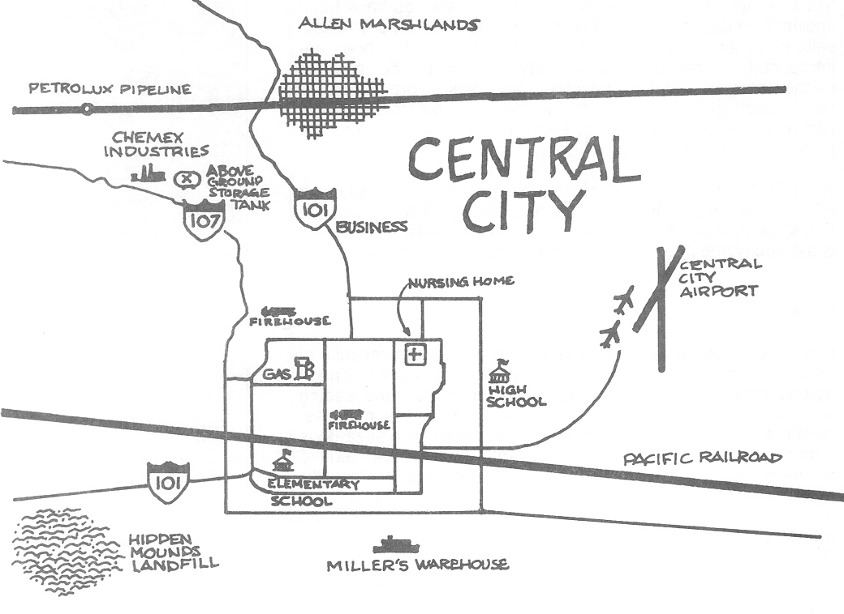

- What impact would a hazardous materials incident cause on the Central City Elementary School? What resources does Central City have to respond to such an incident?

- What industries within Central City would be required to provide Tier I and II Reports to the LEPC? Why are these reports important?

- Where would you logically look for a Commodity Flow Survey of your area to identify what materials are being shipped through Central City via all transportation arteries?

- What are the dangers of TIC? Why are they so hazardous to “first responders?”

- What are some signs that a chemical or biological agent may have been released in the Central City area?

- What steps can the average citizen take to limit his/her exposure to CWA agents as well as a release of a TIC?

CHECK YOUR MEMORY
(Answers are on page C-4)

- The best source for information on where hazardous materials are stored or released from fixed sites in your community is usually:

  - The mayor’s office
  - Your Congressional representative
  - The LEPC
  - Individual manufacturers

- On which of the following might you find an NFPA 704 label?

  - A truck
  - A storage tank
  - A train
  - A package

- You find on an NFPA label that the left side of the quadrant, which is blue, has a rating of 4. This means that:

  - The material offers no unusual health hazard
  - A very short exposure to the substance could cause serious injury or death
  - The chemical is unstable, and may explode or react
  - In 4 minutes of exposure to this substance, you will lose consciousness

- The symbol W on an NFPA label means that:

  - The substance will not dissolve in water
  - The substance is slippery when wet
  - You should not add water to the substance
  - You should keep the substance wet at all times

- DOT requires highway cargo tanks and railroad tank cars with regulated hazardous contents to bear a four-digit number identifying the load if they are:

  - In high-hazard areas
  - Moving in interstate commerce
  - Listed as extremely hazardous
  - Acutely toxic

- The CWA that interferes with the body’s ability to transfer oxygen to the cells is:

  - VX
  - CN
  - CG
  - AC

- Results of Commodity Flow Surveys which outline the types of hazardous materials being shipped through your community can be obtained from:

  - FEMA
  - LAPD
  - LEPC
  - SEMA

